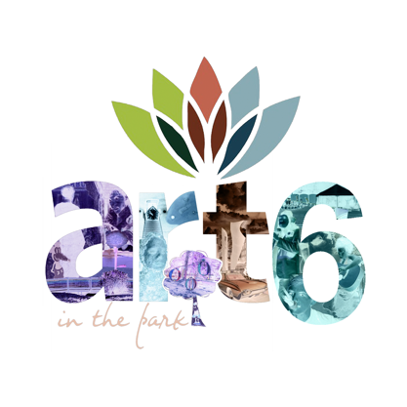

Annual Art in the Park
Business/Organization Sculpture and Installation Competition

Our objective is to create an artistic experience for the participants and viewers.

Guidelines:
- Any safe materials may be used, but none may be new. Upcycle!
- Sculpture or installation should be life sized or larger.
- Sculpture must be family friendly.
- Sculptures may be based on nature, personal experience or abstraction.
- Use of color, texture and scale is encouraged.
- Park friendly materials must not damage plant or animal life.
- Sculpture and installation should take into consideration where it will be placed it should adapt to its environment.
- Sculpture floated in pond must be water and fish friendly.
- Sculpture hung from trees must be light enough to cause no damage.
- Consider materials for sturdiness, availability, wind stability, and ease of transportation to the site.

The sculpture entry fee for businesses is $35 and gives you the option of setting up an information booth for your business. The sculpture submission is a requirement.

The winner of the business/organization sculpture contest will receive the right to choose the local charity to receive the total of all entry fees. (Example: If 25 businesses participate, $875 will be given to one charity off of our approved list, recipient chosen by winner of competition).

Installations begin at 8:00am and must be completed by noon. Winners will be chosen at 3:00pm.

An information meeting will take place in April for those needing assistance/ideas. Check the website at iredellartscouncil.org for upcoming details.

The following information must be submitted to the Iredell Arts Council by May 22, 2020 if you are submitting a sculpture, this may be emailed to iredellartscouncil.org or submitted through Brown Paper Tickets with your payment.

Business/Organization Name
Title of Sculpture
Contact Information
Booth or No Booth

Make your payment of $35 here: https://www.brownpapertickets.com/event/4555772

